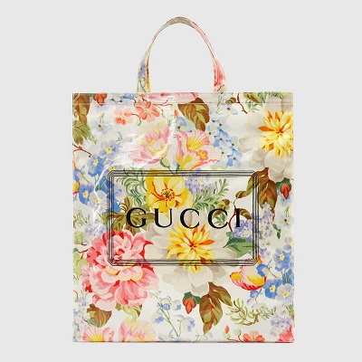

Medium Gucci print floral tote

PRODUCT DETAILS

**The tote bag is crafted from a soft and lightweight cotton fabric with a floral motif,**

**printed with the Gucci logo and specially coated. The unlined silhouette has a clean**

**interior with a removable bottom support that is completed with a leather Gucci label**

**that doubles as a pull tab for easy removal.**

**Double handles with 5" drop • Made in Italy**